Information and Tools to Guide Landscape Conservation in the Appalachians
The Appalachian Landscape Conservation Cooperative (LCC) funds research that addresses the conservation community’s top science needs and develops tools to enhance landscape conservation within the region. By identifying, prioritizing, and supporting fundamental scientific research, the LCC is fostering the development and effective application of vital information and products to help plan and manage for the conservation of aquatic and terrestrial systems throughout the region.
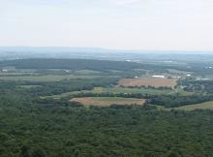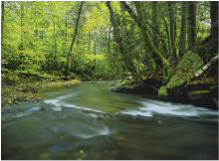
Appalachian LCC Funded Research and Science Products
Assessing Future Energy Development across the Appalachians
This tool enables decision makers to evaluate the scale, scope, and intensity of potential energy development in the Appalachian LCC region. The map visualization tool highlights potential impacts at a landscape scale in order to assist the development of strategies that avoid and mitigate impacts to areas important for regional biodiversity.
Products  - Models of future development potentials for coal mining, gas drilling, and wind farm creation  - Web-based map visualization tool with spatially  explicit energy development projections  Principle Investigator  - Judy Dunscomb, Senior Conservation Scientist, The Nature Conservancy: jdunscomb@tnc.org  Learn more  - Energy Assessment Research and Tools Page - http://applcc.org/assessing-future-energy- development | 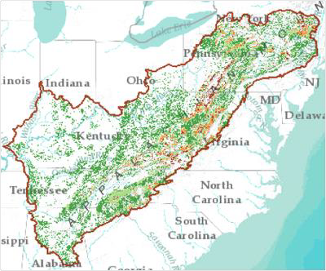  Mapping tool can display data layers showing intersection between potential high probability energy development and important natural resources.

Classification and Mapping of Cave and Karst Resources
Researchers assembled and summarized pre-existing efforts to collect and present karst resource information and then identified the most appropriate classification system to use for karst habitats within Appalachia. Intricate models were developed to further classify the diversity within known cave and karst formations as well as generated predictions on what level of biodiversity might be expected in cave and karst systems.
Products  - Maps and spatial datasets for examining relationships between environmental factors, biodiversity, and distribution within karst areas  - Visual survey guides users through research accomplishments as well as identifies new questions to tackle for future research  Principle Investigator  - David Culver, Professor Emeritus, American University: dculver@american.edu  Learn more  - Cave and Karst Classification and Mapping Research Area - http://applcc.org/classification- mapping-cave-karst-resources | 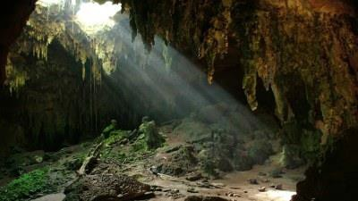  Protecting the beauty and mystery of caves as well as the distribution and richness of biological life within karst landscapes is a bold scientific and conservation challenge.
Climate Change Vulnerability in the Appalachians
This collection of assessments looks at how vulnerable 41 species and 3 habitats in the Appalachian region are to climate change. Users can search assessments by relative vulnerability scores, conservation status rankings, higher taxonomy, and state or subregion of interest, as well as explore previously completed assessments for 700 species and several habitats compiled by past research.

Products
- New Climate Change Vulnerability Assessments of 41 Species and 3 Habitats
- Previous Climate Assessments for 700 Species
- Final Report: Climate Change Vulnerability Assessments in the Appalachian LCC Region

Principle Investigator
- Lesley Sneddon, National Ecologist, NatureServe: Lesley_Sneddon@natureserve.org

Learn More
- Climate Change Vulnerability Research Page - http://applcc.org/research/climate-change- vulnerability
Ecosystem Benefits and Risks
This clearinghouse of research, datasets, and maps provide resources for planners, managers, and citizens to understand essential services that nature provides people, and assess threats to sustaining them in the Appalachians in the face of climate change and other drivers of landscape change.

Products  - Descriptions of regional ecosystem services  - Identification of threats to regional ecosystem services  - Conservation Atlas of ecosystem services with access to collections of data layers and maps  Principle Investigator  - Lars Pomara, Ecologist, U.S. Forest Service: lazarusypomara@fs.fed.us  Learn more  - Ecosystem Services Conservation Atlas - http://applcc-ecosystemservices.org/  - Ecosystem Benefits and Risks Research Area - http://applcc.org/ecosystem-risks-benefits | 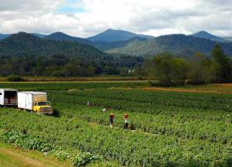  This clearinghouse of information and tools integrates the societal value of ecosystem benefits with future threats to inform planning and management.
Landscape Conservation Design
This modeling effort identified ecologically significant landscapes and corridors of connectivity that are critical to conserving regional biodiversity into the future. The final design framework will provide public land managers, nonprofit organizations, and private landowners the ability to incorporate landscape data into local decisions and conservation actions.
Products  - Report and videos on phase I and phase II project results  - A map gallery and data displaying spatial extent of the conservation design elements  Principle Investigator  - Paul Leonard, Science Coordinator, Artic LCC paul_leonard@fws.gov  Learn more  - Appalachian LCC Landscape Conservation Design Research Page -http://applcc.org/research/interactive- conservation-design | This map represents the near optimal solution identified in phase II of the Landscape Conservation Design.
Riparian Restoration Decision Support Tool
This tool identifies streams and riverbanks that lack tree cover and shade for vulnerable cold-water stream habitats. By locating the best spots to plant trees in riparian zones, resource managers can provide shade that limits the amount of solar radiation heating the water and reduces the impacts from climate change.

Products
- Final Report: Riparian Prioritization and Status Assessment for Climate Change Resilience of Coldwater Stream Habitats within the Appalachian and Northeast Regions
- Riparian Restoration for Climate Change Resilience Decision Support Tool

Principle Investigator
- Jason Coombs, Conservation Ecologist, UMass Amherst: jcoombs@cns.umass.edu

Learn more
- Riparian Restoration Research and Tools Page – http://applcc.org/riparian-restoration
Stream Impacts from Water Withdrawals in the Marcellus Shale Region
How may the region’s surface freshwater supply – and the health of natural systems delivering this resource – be impacted and altered in the coming years under increasing water withdrawals. Using sophisticated modeling techniques, researchers tested and identified various flow regimes to help resource managers, industry and others make more informed decisions in ach ieving sustainable river and stream flows that balance the needs of society and healthy ecosystems.
Products  - Final Report: Environmental Flow Analysis for the Marcellus Shale Region  - Inventory of flow models and underlying data sources from instream monitoring networks  Principle Investigator  - Todd Walter, Director, New York State Water Resources Institute: mtw5@cornell.edu  Learn more  Stream Impacts from Water Withdrawal Research Page - http://applcc.org/research/stream-impacts- water-withdrawals | 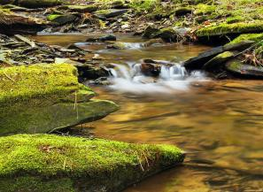  A balance between human needs and flows needed to sustain aquatic ecosystems can be realized if water withdrawal regulations vary with stream size and season.
Stream Classification System
This consistent classification system and map for stream and river systems represents natural flowing - water aquatic habitats across the entire Appalachian region. By bringing together existing geomorphic and hydrologic classifications systems from different states, this product can be used to inform conservation decisions that will offer the greatest long-term benefit for regional aquatic ecosystems.

Products
- Shapefiles and metadata of the stream classification
- Data on stream chemistry, confinement, gradient, stream size and hydrologic classes
- Literature review, final report, and story map on stream classification system

Principle Investigator
- Arlene Olivero Sheldon, Aquatic Ecologist, The Nature Conservancy: Arlene_olivero@tnc.org

Learn more
- Stream Classification Research Page - http://applcc.org/research/stream-classification
LEARN MORE ABOUT LCC SCIENCE
Appalachian LCC: http://www.applcc.org/ Contact: communications@applcc.org

